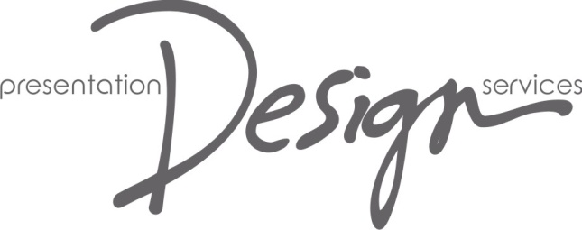

**JOB DESCRIPTION**

**The Role:** Sewing Machinist /Production Technician (Drapes)

**Based:** Presentation Design Services, Alfreton

**Reports To:** Workroom Manager

**Start Date:**  As soon as possible

**Outline:**  The role of Drapes Production Technician is to manufacture fabric items as required by the Company and our clients

**Purpose**

To work under the instruction of the Workroom Managers to make fabric items as required to the Company house style and standards. To operate as part of the workroom team, following instructions, being proactive and communicating clearly.

**Responsibilities**

To use the Company’s sewing machines, overlocker and other workroom equipment to manufacture theatrical drapes and other fabric items as required by our customers and internal Company departments.

To liaise with the Workroom Managers regarding work schedules and priorities, which may change throughout the day, and to implement any changes in a timely manner.

Help keep the Drapes workspaces clean and tidy and clear of risks.

Report haberdashery and fabric stock shortages.

Report problems or concerns with equipment.

Assist with the ongoing maintenance of Company stock drapes.

To be pro-active about identifying tasks that need carrying out.

To be communicative and predictive about workload and any potential problems that may arise.

To work according to Company health and safety policies and ensure own best practice; to report any concerns regarding the work of others or any other health and safety issue.

To support the work of the Company as a whole, including the Events and Dry Hire departments.

To carry out any other tasks reasonably required to assist with the smooth operation of the Drapes department and the Company as a whole.

Attend and contribute to Company events and department meetings.

Be willing to work with and alongside any other area of PDS as and when required.

Suggest any appropriate training courses that may help improve both yourself and PDS processes.

**Attitudes**

At PDS we believe that service and delivery is everything. We want to provide a better, more professional service than our competitors. You are expected to carry this ethos through in your day-to-day work, both at the Company's base and anytime you are working for us away from base.

**Work-Focussed**: have excellent attention to detail and be aware of what is happening elsewhere in the workroom.

**Approachable**: maintain a friendly and approachable demeanour at all times.

**Team Player**: work well with others, communicate clearly, show tolerance.

**Results-driven**: strive for excellence by being positive and delivering results wherever possible.

**Supportive**: follow instructions of managers and assist colleagues whenever necessary

**Invested & Enthusiastic**: commit to the Company’s values outlined in the This Is Us document. Show enthusiasm and passion for your work, with a desire for continuous improvement.

**Professional & Diplomatic**: act as a PDS representative at all times, always maintaining a high level of customer service and attention to detail. Publicly support the Company (ie in front of staff, suppliers and customers) and raise any concerns privately with managers.